Assignment: Database Creation for Sunbeam Online Student Portal

ER Diagram
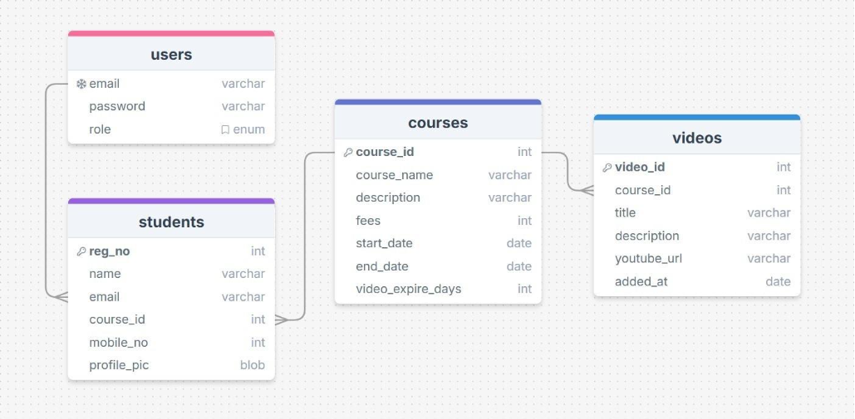

Assignment Description
Assignment: Database Creation for Sunbeam Online Student Portal
Using the provided ER Diagram, design and implement the complete MySQL database for the Sunbeam Online Student Portal project.

Your Tasks
- Create the database in MySQL as per the ER diagram
- Select the database using the appropriate SQL command.
- Create all tables (users, students, courses, videos) with: Correct data types
Primary keys Foreign keys
Relationships exactly as shown in the ER diagram

Screenshot Requirements
After executing every SQL command, you must take a screenshot showing: The command you executed

- CREATE DATABASE online_portal;
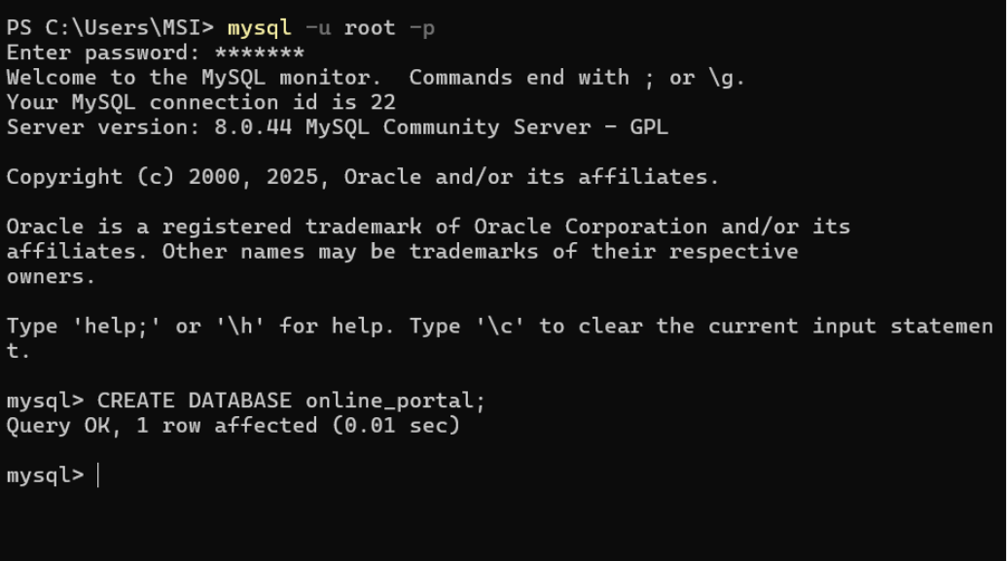

(select database)
Use online_portal;
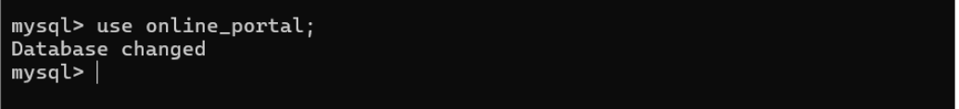

Tables
- users
Command - CREATE TABLE users (email VARCHAR(100) PRIMARY KEY, password VARCHAR(255) NOT NULL, role ENUM('ADMIN','STUDENT') NOT NULL);
Output - Query OK, 0 rows affected (0.02 sec)
Screenshot -
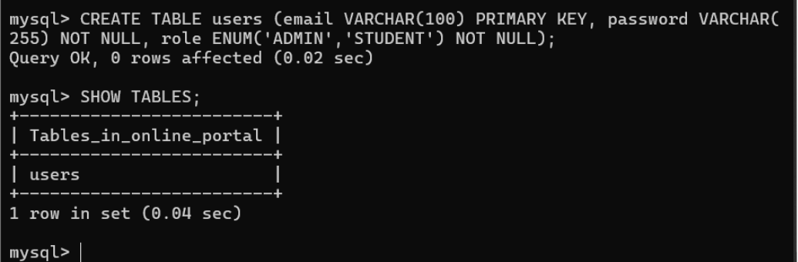

- courses

Command - CREATE TABLE courses( course_id INT PRIMARY KEY AUTO_INCREMENT, course_name VARCHAR(100) NOT NULL, description VARCHAR(255), fees INT, start_date DATE, end_date DATE, video_expire_days INT);
Query OK, 0 rows affected (0.07 sec)
Screenshot -
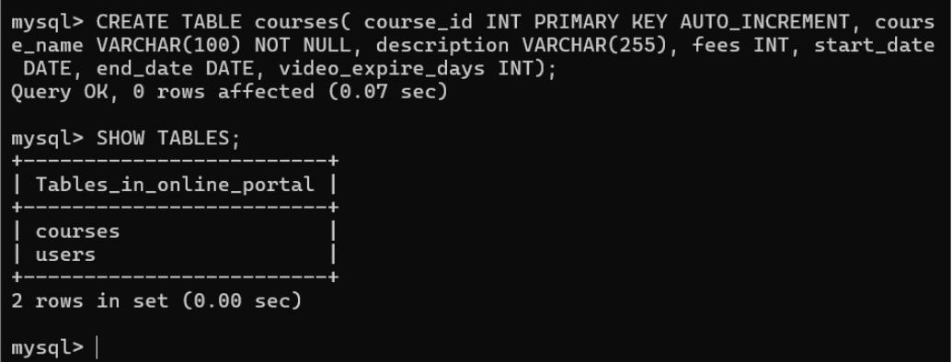

- students

Command - CREATE TABLE students( reg_no INT PRIMARY KEY AUTO_INCREMENT, name VARCHAR(100) NOT NULL, email VARCHAR(100), course_id INT, mobile_no BIGINT, profile_pic BLOB, FOREIGN KEY(email) REFERENCES users(email) ON DELETE CASCADE ON UPDATE CASCADE, FOREIGN KEY(course_id) REFERENCES courses(course_id) ON DELETE SET NULL ON UPDATE CASCADE);
Query OK, 0 rows affected (0.12 sec)
Screenshot -
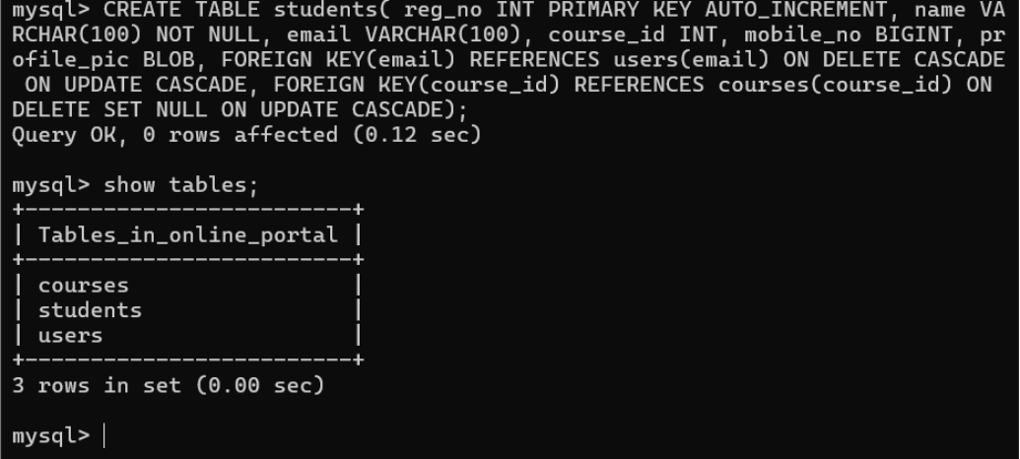

4. videos

Command - CREATE TABLE videos (
-> video_id INT AUTO_INCREMENT PRIMARY KEY,
-> course_id INT NOT NULL,
-> title VARCHAR(155),
-> description VARCHAR(255),
-> youtube_url VARCHAR(255),
-> added_at TIMESTAMP DEFAULT CURRENT_TIMESTAMP,
-> CONSTRAINT fk_videos_courses
-> FOREIGN KEY (course_id)
-> REFERENCES courses(course_id)
-> ON DELETE CASCADE
-> ON UPDATE CASCADE
-> );
Query OK, 0 rows affected (0.13 sec)

Screenshot -
